**Lab report no 7**



**Fall 2021**

# Computer Architecture and organization Lab

**Submitted By**

**Names Registration No**

# Muhammad Ali 19pwcse1801

Section: **A**

**Date**: 19,2,21

**Submitted to:**

**Dr Amaad khalil**

Department of Computer Systems Engineering

University of Engineering and Technology, Peshawar

**Task no 1: -**

**Code: -**

.data

msg1: .asciiz "Muhammad Ali 19pwcse1801 \nenter temp in farenheight "

msg2: .asciiz "\ntemp in celsius is"

f: .float 32.0

f1: .float 0.555

.text

lwc1 $f2, f

lwc1 $f5, f1

li $v0, 4

la $a0, msg1

syscall

li $v0, 6

syscall

mov.s $f1,$f0

sub.s $f3,$f1, $f2

mul.s $f4,$f3, $f5

li $v0, 4

la $a0, msg2

syscall

mov.s $f12, $f4

li $v0 ,2

syscall

li $v0, 10

syscall

**Register: -**

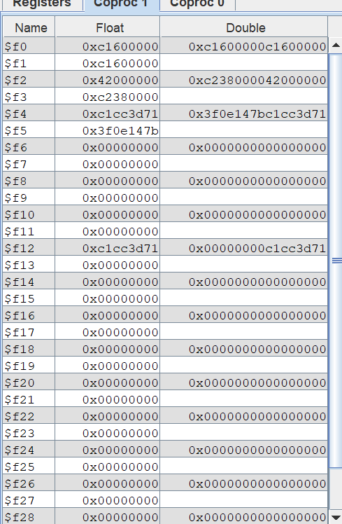

**Consul: -**

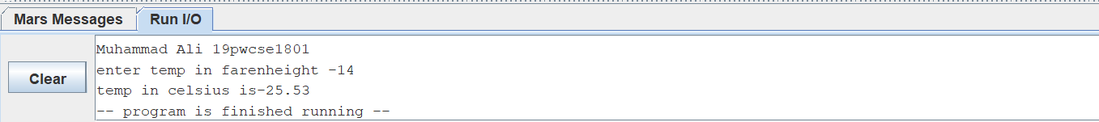

**Task no 2: -**

**Code: -**

.data

msg1: .asciiz " Muhammad Ali 19pwcse1801 quardral GPA calculation\n"

gpa1: .asciiz " enter first subject GPA "

ch1: .asciiz " \nenter credit of first subject "

gpa2: .asciiz " \nenter second subject GPA "

ch2: .asciiz " \nenter credit of second subject "

gpa3: .asciiz " \nenter third subject GPA "

ch3: .asciiz " \nenter credit of third subject "

gpa4: .asciiz " \nenter fouth subject GPA "

ch4: .asciiz " \nenter credit of fourth subject "

result: .asciiz " GPA = "

.text

li $v0, 4

la $a0, msg1

syscall

li $v0, 4

la $a0, gpa1

syscall

li $v0, 6

syscall

mov.s $f1, $f0

li $v0, 4

la $a0, ch1

syscall

li $v0, 6

syscall

mov.s $f2, $f0

li $v0, 4

la $a0, gpa2

syscall

li $v0, 6

syscall

mov.s $f3, $f0

li $v0, 4

la $a0, ch2

syscall

li $v0, 6

syscall

mov.s $f4, $f0

add.s $f9,$f3,$f1

add.s $f10, $f4,$f2

li $v0, 4

la $a0, gpa3

syscall

li $v0, 6

syscall

mov.s $f5, $f0

li $v0, 4

la $a0, ch3

syscall

li $v0, 6

syscall

mov.s $f6, $f0

add.s $f9,$f9,$f5

add.s $f10, $f4,$f6

li $v0, 4

la $a0, gpa4

syscall

li $v0, 6

syscall

mov.s $f7, $f0

li $v0, 4

la $a0, ch4

syscall

li $v0, 6

syscall

mov.s $f8, $f0

add.s $f9,$f9,$f7

add.s $f10, $f4,$f8

div.s $f1,$f9, $f10

#mflo $f3

li $v0, 4

la $a0, result

syscall

mov.s $f12, $f1

li $v0 ,2

syscall

li $v0, 10

syscall

**Register: -**

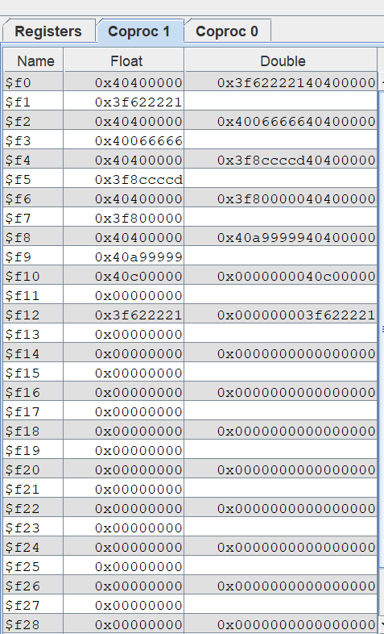

**Consul: -**

